Integration with Crosswork Network Automation and NSO
1. Drives Automated Service Assurance and Service Lifecycle Management
The main challenges solved are in the areas of simplification and acceleration of service assurance provisioning and reducing errors and mistakes. Multiple business and technical outcomes can be realised, which include more rapid deployment of assured services, reduction of complexity, and also enabling closed-loop scenarios.
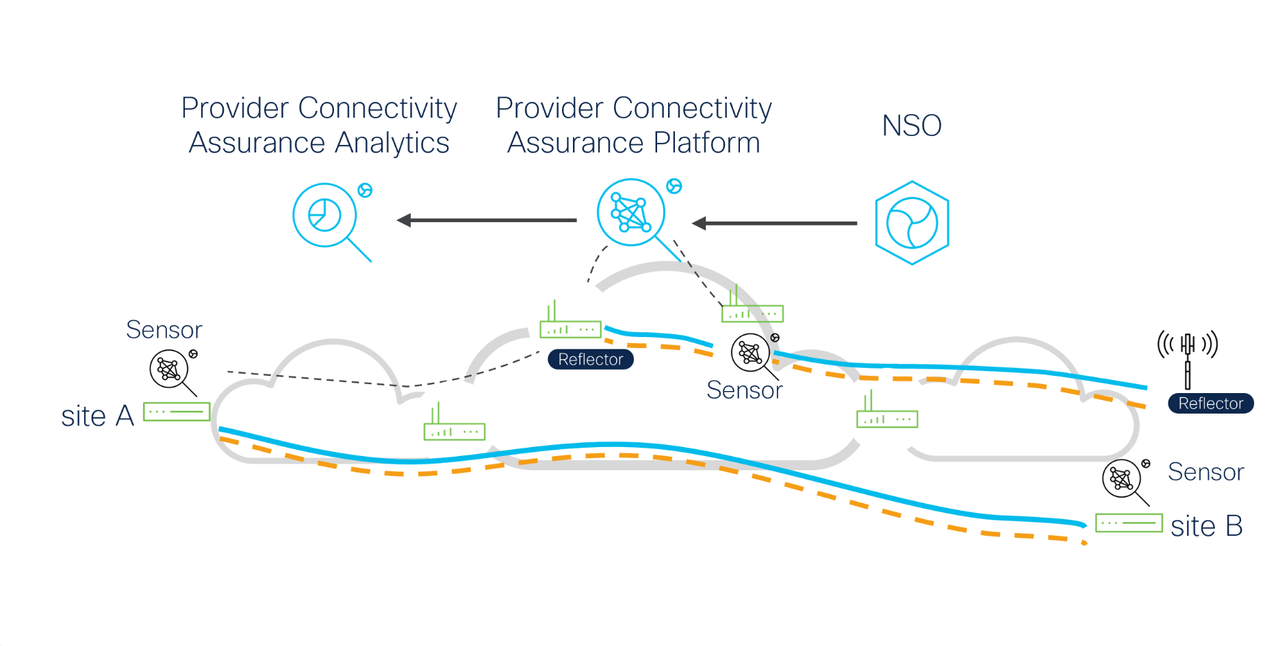

2.Provider Connectivity Assurance with NSO
The Provider Connectivity Assurance (PCA) platform is integrated into NSO via a Network Element Driver (NED). The NED was developed by Cisco’s NSO team and the API based on RESTConf/YANG in the PCA platform was developed by the PCA team. Note that in future releases, the orchestration layer within Skylight will evolve, which will likely require a rework of the NED.
Cisco Provider Connectivity Assurance is integrated into NSO to:
- Automate provisioning of service assurance
- Drive closed-loop scenarios
- NSO to receive alerts from Provider Connectivity Assurance
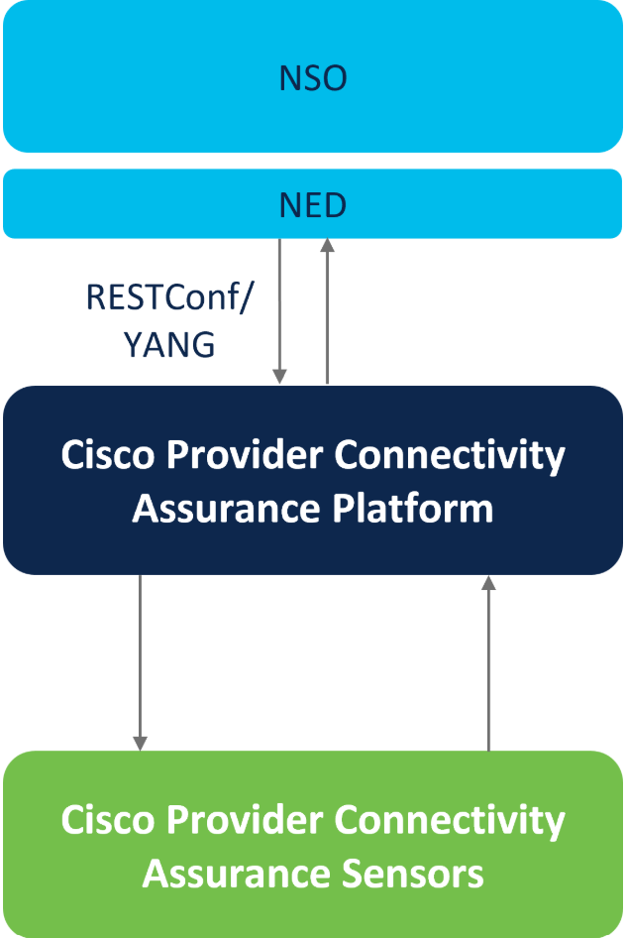

3. Provider Connectivity Assurance with NSO – Why
Why has this integration been done? It’s really focused on three areas as shown on the screen.
- Enable automated provisioning of service assurance
Simple and rapid deployment of assurance capability
- Provide feedback from the assurance solution back to the orchestration and control layers
Drive action for process improvement and enable complex use cases of assurance capability
- Single solution formulti-vendor, multi-domain transport technologies and associated assurance
Reduce number of vendors, give confidence that the assurance is an integral part of the overall offering
4 Cisco Provider Connectivity Assurance and NSO
Soluton Components
Currently, there are two modes of operation of the Provider Connectivity Assurance (PCA) Gateway. For working with NSO, the gateway needs to be built and deployed in NSO Gateway mode and NOT PCA Gateway mode, which is used with CNC. This orchestration and gateway function will evolve over time, which may trigger a slight rework to the PCA NED with the NSO team.
Note that the PCA platform is shown abstracted into three components, with a “gateway” function over the top.
The capabilities described are based on the following solution components:
- NSO with Provider Connectivity Assurance NED
- Provider Connectivity Assurance Platform with the following services enabled:
  - Provider Connectivity Assurance Gateway*
  - Provider Connectivity Assurance Analytics
  - Agent and embedded sensor orchestrators
- Assurance Sensors: Agent, Sensor Control + SFP

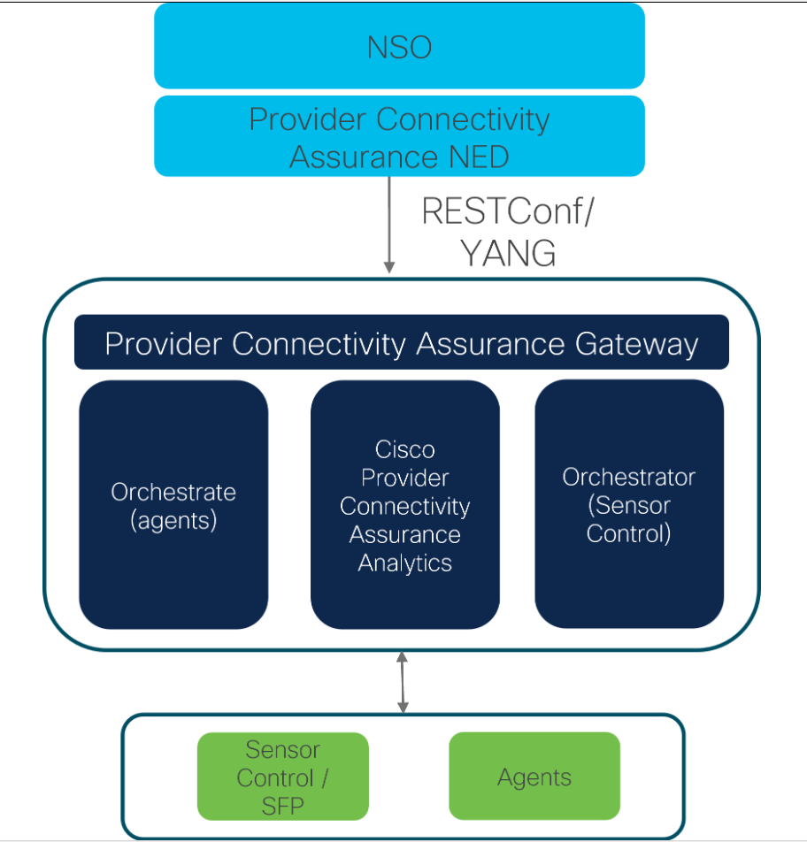

* NOTE: Provider Connectivity Assurance Gateway service has two modes of operation:
1. PCA Gateway – used for intent based service assurance use cases with CNC
2. NSO Gateway – used primarily as a RESTConf to REST passthrough interface for NSO

5. Drives Intent-Based Assurance and CNC Service Health
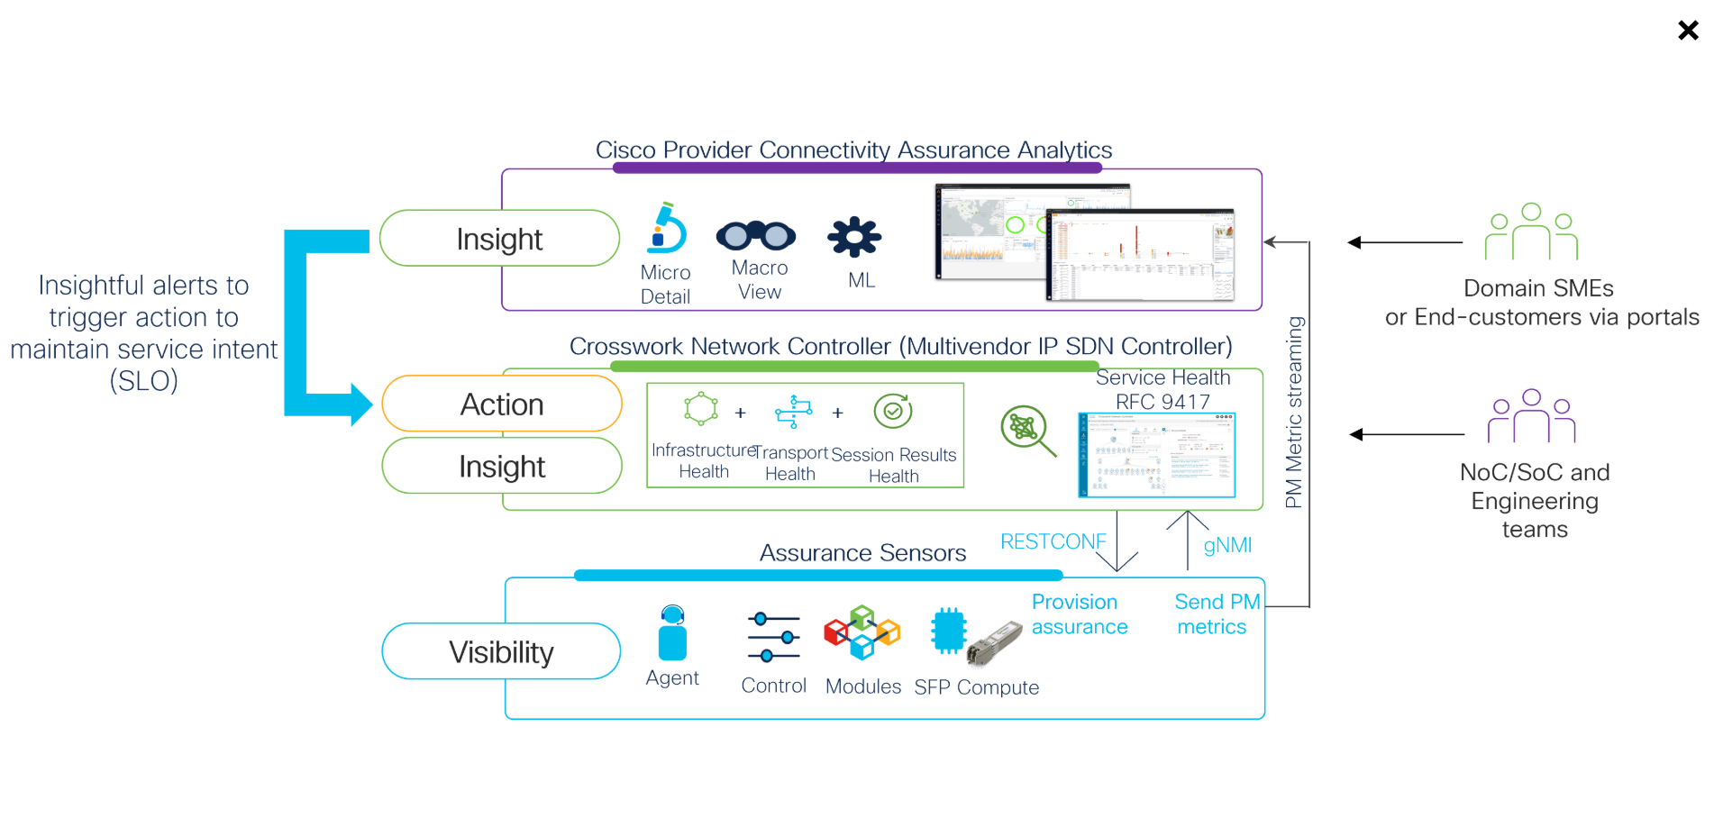
In this case, provisioning is also a key focal area, in common with NSO. The main difference with the challenges solved with this integration is the fact that CNC uses an abstracted model where a more contextual and service-oriented approach is used regarding how Provider Connectivity Assurance (PCA) service assurance is provisioned; intent based assurance.
The other challenges are common with the NSO use case are:
- Reduction of human error
- Speeding up deployment of assurance
- Enabling dynamic services
The solution starts in CNC 6.0 as an LA release but a more complete feature set is coming in CNC 7.0 GA and beyond. In CNC 7.0, provisioning of service assurance sessions across the full suite of PCA sensors is supported and in addition, PCA metrics are used to drive Service Health workflows and dashboards. Multiple operational benefits can be realised along with enablement of an intent-based approach to service assurance.
Challenge
- Manual provisioning of service assurance on a large scale can be onerous
- Significant potential for human error and extended time to deploy
- Modern services and transport layers are dynamic in nature; assurance needs to be as well
- Industry move towards intent-based networking
Solution
- From CNC 6.0 onwards, aspects of PCA are part of the intent-based automated workflow; more will come in CNC7.0 GA
- CNC provisioning workflows add service assurance to MPLS-SR/SRv6 transport and Layer 3 service VPNs
- Pass PCA metrics to CNC (via CDG) to drive RFC-9417 service health functions and workflows to ensure the service remains in compliance with the business objectives (SLO)
Outcome
- Reduce OpEx by simplifying provisioning and lifecycle management of service assurance
- Enable a dynamic intent-based approach to service assurance; proactively improve QoE and customer satisfaction
- Consolidate transport, service VPN, and service assurance provisioning into one platform: lower CapEx
6 Provider Connectivity Assurance with CNC
Provider Connectivity Assurance (PCA) is integrated into CNC in two ways. For provisioning, the PCA gateway is used and talks RESTConf/YANG with CNC directly; note, NSO is not used here, and CNC talks directly to the PCA platform. In the reverse direction, PCA metrics are passed to CNC via CDG (Cisco Data Gateway) over a streamed gNMI interface. These two integrations enable multiple areas of capability, as shown.
Cisco Provider Connectivity Assurance is integrated into CNC to:
- Automate provisioning of service assurance at the same time as the transport and/or service VPNs
- Drive intent-based networking
- Send service assurance KPIs to CDG so they are available to CNC users (Service Health)
- CNC to receive alerts from Provider Connectivity Assurance to drive closed-loop scenarios
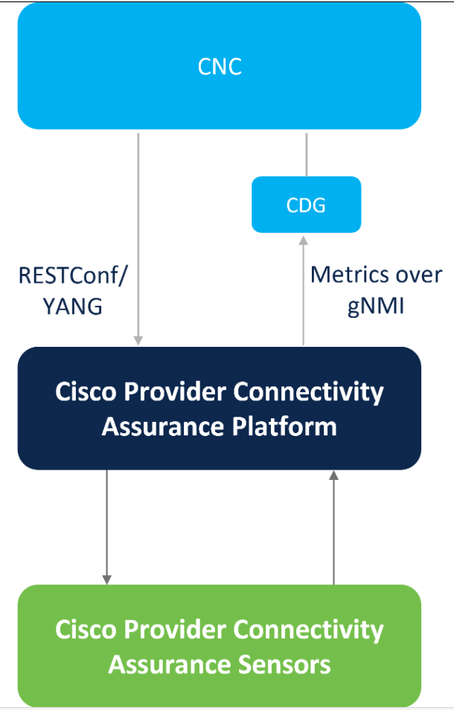
7 Provider Connectivity Assurance with CNC – Why?
Why have we done this and why will we evolve this over time? There are 3 main reasons:
- Enable Cisco to offer critical-network service assurance metrics within multiple CNC Service Health workflows and dashboards
- Provide feedback from the PCA layer into CNC to drive “action”, along with enabling intent-based networking
- Along with enabling intent-based networking, which has automated contextual provisioning of assurance as an included capability.
- Enable Cisco to offer critical-network service assurance metrics within CNC
Drives CNC service health
- Provide feedback from the assurance solution back to the orchestration and control layers
Drive action for process improvement and enabling complex use cases
- Drive intent based networking
Evolved assurance layer with service-based intelligence
8 NSO is also used "Internally" by CNC for Provisioning
One final note. Provider Connectivity Assurance (PCA) is currently integrated with NSO and CNC as separate tracks. They both share a common gateway function in the PCA platform, which has two modes depending on the usage. The orchestration and gateway function will evolve over time. CNC also uses NSO “under the hood” for multi-vendor provisioning functions, but this is NOT used with PCA and CNC has a native RESTConf/YANG based API for such provisioning.
Remember: Today we have two different Provider Connectivity Assurance Gateway Modes:
- Provider Connectivity Assurance Gateway (for CNC)
  - NSO NED and NSO Gateway will be updated to converge with this model
- Provider Connectivity Assurance NSO Gateway
NSO not used under CNC for Provider Connectivity Assurance, but for other third-party devices
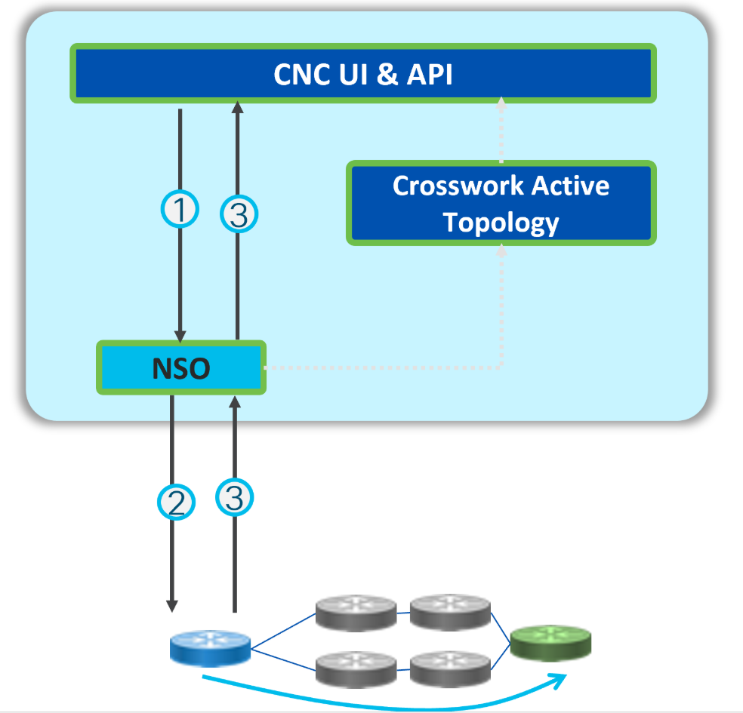
Simplified provisioning steps
Step 1
User requests to create a service
Step 2
NSO creates device configurations for service and pushes it to the devices
Step 3
Validation feedback is provided

